Name:Aryan mishra
Branch & Year: CSE, First Yr.
Section: c

Aim: Create a result Script taking marks of five subject as input and calculate marks and average using javascript function

Code:

<html>
<head>
<meta charset="UTF-8">
<meta name="viewport" content="width=device-width, initial-scale=1.0">
<title>Calculate Result</title>
</head>
<body>

<script>
function calculateResult() {
const subject1 = parseFloat(document.getElementById('subject1').value);
const subject2 = parseFloat(document.getElementById('subject2').value);
const subject3 = parseFloat(document.getElementById('subject3').value);
const subject4 = parseFloat(document.getElementById('subject4').value);
const subject5 = parseFloat(document.getElementById('subject5').value);

if (isNaN(subject1) || isNaN(subject2) || isNaN(subject3) || isNaN(subject4) || isNaN(subject5)) {
alert("Invalid input. Please enter valid numerical values for all subjects.");
return;
}

const totalMarks = subject1 + subject2 + subject3 + subject4 + subject5;
const averageMarks = totalMarks / 5;

let grade = "";
if (averageMarks >= 90) {
grade = "A+";
} else if (averageMarks >= 80) {
grade = "A";
} else if (averageMarks >= 70) {
grade = "B";
} else if (averageMarks >= 60) {
grade = "C";
} else {
grade = "D";
}

const resultMessage = `
Total Marks: ${totalMarks.toFixed(2)}
Average Marks: ${averageMarks.toFixed(2)}
Grade: ${grade}
`;

alert(resultMessage);
}
</script>

<h2>Enter Marks for Five Subjects:</h2>
<label for="subject1">Subject 1:</label>
<input type="text" id="subject1">

<label for="subject2">Subject 2:</label>
<input type="text" id="subject2">

<label for="subject3">Subject 3:</label>
<input type="text" id="subject3">

<label for="subject4">Subject 4:</label>
<input type="text" id="subject4">

<label for="subject5">Subject 5:</label>
<input type="text" id="subject5">

<button onclick="calculateResult()">Calculate Result</button>

</body>
</html>

Screenshot Output:
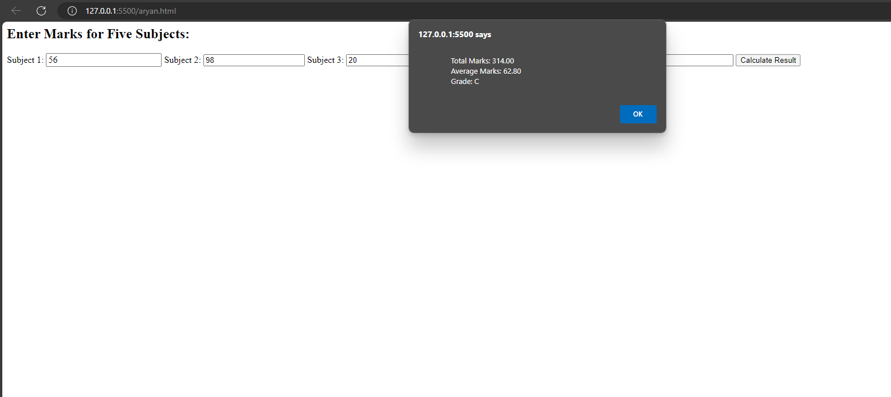
Conclusion: successfully studied how to Create a result Script taking marks of five subject as input and calculate marks and average using javascript function

